Home Away From Home

# statement of Purpose

The purpose of this project is to build a web application that will simplify the process of finding affordable off-campus housing for incoming and returning students. The web application will highlight the regions of Merced that are the post populated with student housing. Students will be able to locate where the most crimes have occurred around each house or apartment that is for rent. In addition, they will also be able to search for housing based on the nearest Cattrack location. Overall, students will be able to find a house or apartment which best suits their needs.

# data Collection

Before being able to develop the web application we collected all the necessary data to input in our web application. The three major factors that played an important role in our project were student housing crime and Cattrack locations.

Our project focuses on data that will highlight the most suitable places for students to live off-campus. Therefore, we sent out a survey asking students where the live off campus. Through their responses we were able to divide Merced into eight main housing areas, including: Bellevue, El Redondo, R Street, Loughborough, Bear Creek, Downtown, EL Portal and Via Moraga. The survey helped us narrow down were the best locations for student housing would be. The next step of our data collection was finding out what exact houses or apartments were available for rent and convenient for students. UC Merced’s Housing and Residence Life provides students with information on houses and apartments that students are able to rent. Their Off-campus Housing System gave us access to the specific location of the houses and apartments, along with contact information and room availability. With the help of this information we were able to plot markers on a google map that indicated available housing, along with contact information.

In addition of finding student housing, we focused on finding crimes within the main eight regions of Merced we are focusing on. To collect this data we used the website crime mapping which gave us access to the longitude and latitude of each committed crime in Merced. The website classified different types of crimes ranging from a noise complaint to DUIs. Since we were focusing on the safety of students, we decided to record all crime classifications with the exception of noise complaint. Once we recorded the data we used it to create markers on the google map which indicate and specify different crimes committed.

Lastly, we wanted to provide students with a map that will not only allow them to view available student housing and nearby crimes, but would also display available transportation. UC Merced’s Transportation and Parking Services provided us with the location of each bus stop. With this we were able to make the Cattrack markers on our own google map.

When we first searched for the data we collected, we were hoping to obtain the API of both the Off-campus Housing System and Crime Mapping website. However, we were not able to obtain it, therefore we recorded all the raw data of each source into separate excel sheets. We were then able to save these excel sheets as csv files and load them into google maps which would then record each location and display it on the map as a marker. Once all the data was collected and displayed on the map we were able to make conclusions in regards to the best available housing for students.

# Results and conclusions

After analyzing the data we collected, we concluded that the three most convenient and safest areas in Merced for a student to live are Bellevue, El Redondo and Via Moraga. We based these conclusions based on crime rate, student housing population and transportation.

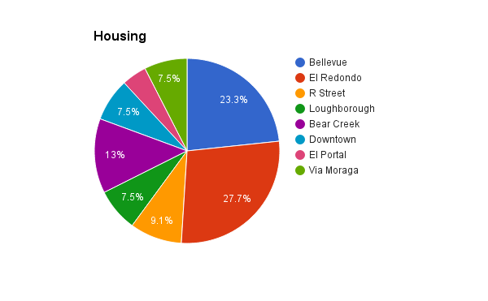

From the survey we provided to students and Off-campus Housing System, we were able to conclude that twenty seven percent of students live in El Redondo Area. The second highest living area was Bellevue with twenty three percent and third highest was Bear Creek with thirteen percent.

Because the majority of the students who live off campus live in the El Redondo area we decided to make it one of the main areas to live. Along with El Redondo, we also decided on Bellevue area due to its high population of students, and as described later, it is also the area with the least amout of reported crime.

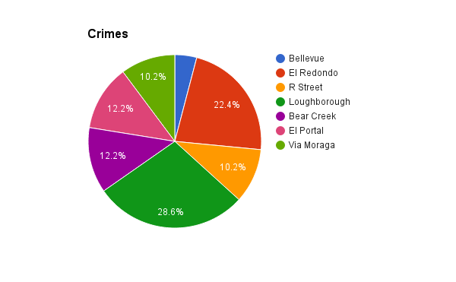

After collecting the crime data we were able to conclude that the area with the most crime rates is Loughborough with twenty eight percent of the recorded crimes. The second highest area was El Redondo with twenty two percent and third were both Bear Creek and El Portal with twelve percent.

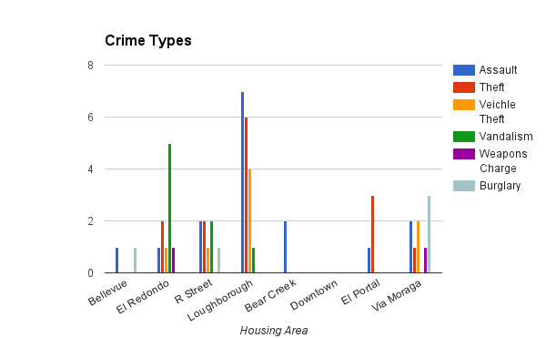Based on the results above, Bellevue and Via Moraga are the safest areas where a student could live. By comparing both the results of housing and crimes, we noticed that although El Redondo is the area with the post population of students, it is also the second highest area with reported crime. The graph below shows the different types of crimes that were reported and the map shows their location.

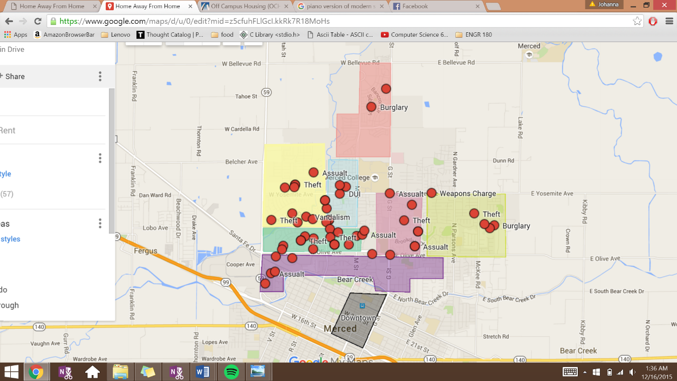

The graph above demonstrates that the most crimes reported were due to assault, theft and vandalism. However, El Redondo has a variety of crimes reported, such as, assault, theft, vehicle theft, vandalism and weapon charge. So why did we chose El Redondo to be one of our main areas for students to live? After collecting our results we also made sure to plot them on our map. By doing this, we were able to visualize that the crimes reported in the El Redondo area were mostly located towards the south, getting close to Loughborough (as seen in the map above).

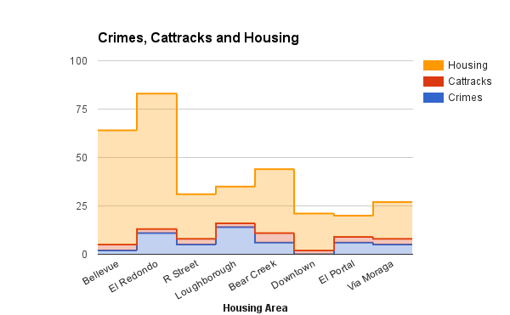

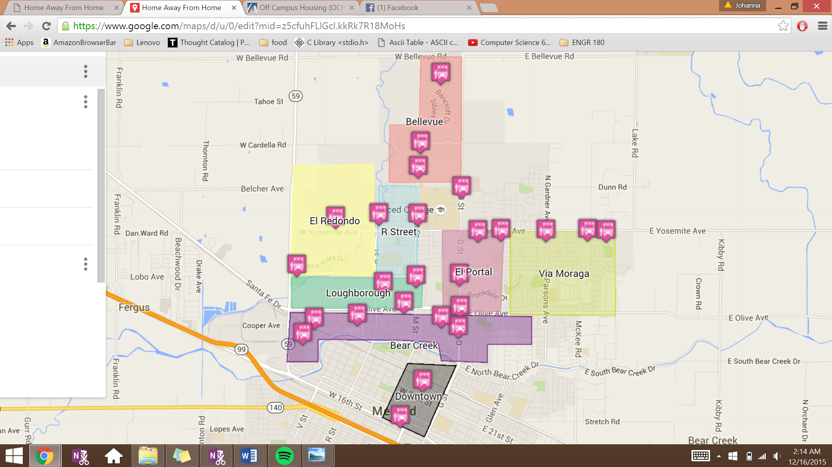

The graph above displays the three factors we took into consideration when choosing the three main living areas. After establishing the most populated and safest areas, we decided to analyze the convenience of transportation. Based on the graph and map above, we concluded that, El Redondo is convenient for those without cars because there are three Cattrack locations within at least ten minutes of walking distance; in addition, the Merced Mall and grocery stores are ten to twenty minute walking distance or five to ten minutes by Cattracks. On the contrary, one may choose not to live in El Redondo due to high crime rates and it is one of the farthest areas from campus. Bellevue is convenient for those students with cars because it is located the closest to campus. Students without cars may be discouraged to choose Bellevue since it is the farthest from shopping centers and grocery stores, however there are a variety of available Cattracks. Via Moraga would be ideal for students with and without cars. There are a variety of Cattracks and there is a nearby shopping center and grocery store; students with cars are also within a ten minute drive to campus. However, the only issue with Via Moraga is that there are less listings for house and apartments for rent.

# Web Application overview

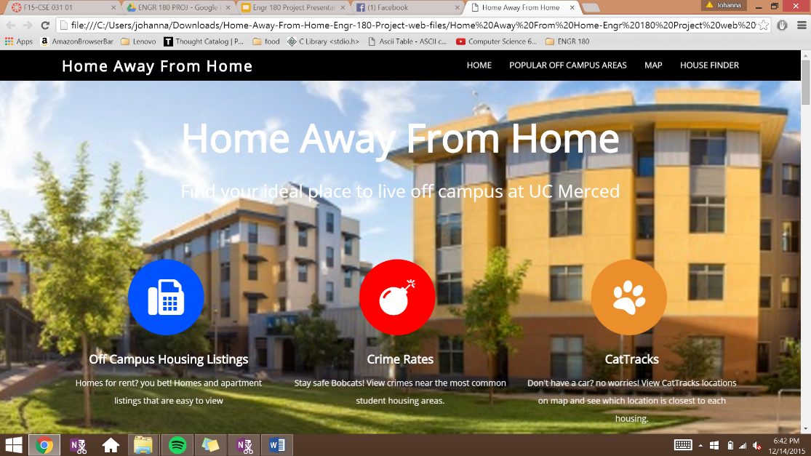

After collecting our data and analyzing our results, we began to incorporate all our information into the web application. Through the process of building our web application we had to learn how to use HTML and JAVA Script. With HTML we were able to build the background and basis of the website, and used JAVA Script to make our searchable database. With these techniques we were able to make a web application with three different components including: housing suggestions, searchable database and a map that marks housing, Cattracks and crimes.

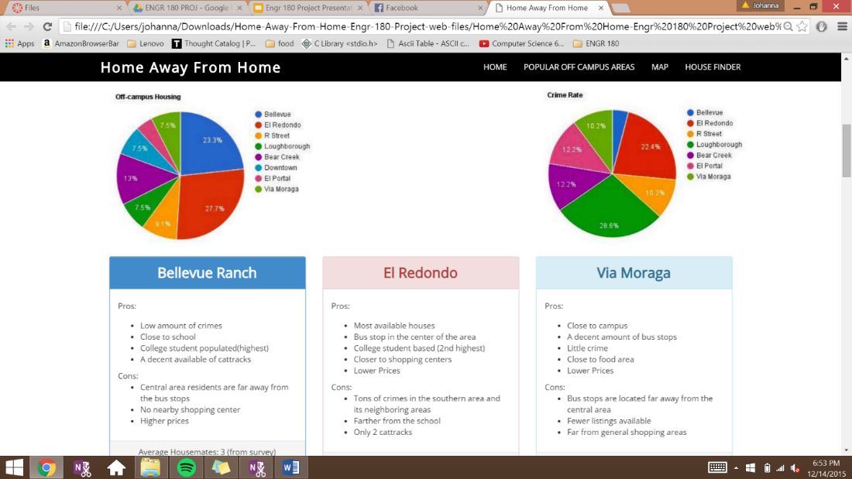

The housing suggestion portion of the website displays the results we received on housing and crimes. Adding the results to the website will allow the user to make a judgement of where there would like to live based on student population or safety. In addition, this portion also includes a pros and cons list of the top three popular off-campus areas. As mentioned before in the results section of the report, these three areas were selected based on their safety, student population, transportation availability and its vicinities. To further expand this portion of the website, we could include a pros and cons list of all the different areas we selected to give the user more options. Due to a lack of experience with HTML, we were only able to make space for three slots, therefore we were only able to display the top three areas.

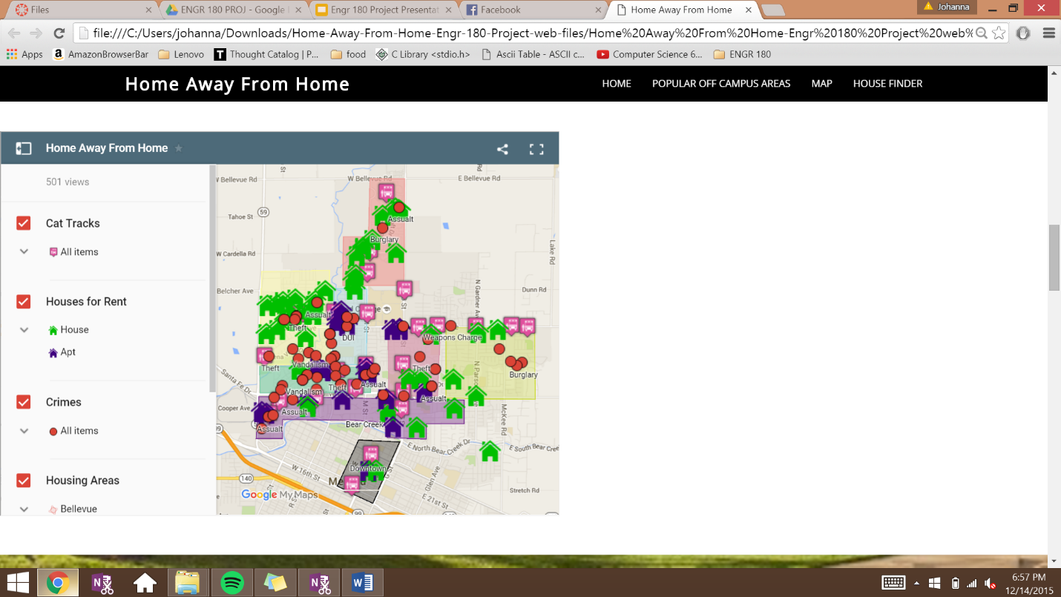

One of the methods students could use to search for housing is our interactive google map. To make the google map, we first decided to try to hard code it on our own to make interactive markers. We used w3schools.com to guide us with HTML basics. However, since we had no experience with HTML, it would have taken us longer that the given time to complete this project. Therefore, we managed to use google maps to create our own map that would display all the housing and apartment locations, crime locations, and bus stop locations. The map consists of four different layers (housing areas, houses for rent, crime and Cattracks) which the user can select as they please. In addition, when selecting a house or apartment of interest, the map will display on the side the contact information. Similarly, when clicking on a crime marker, it will display what type of crime was committed. The map can be viewed in a larger screen by clicking “view larger map” on the upper rightmost toggle. Similarly, the map can also be shared by clicking “share” on the toggle left side of the “view larger” toggle.

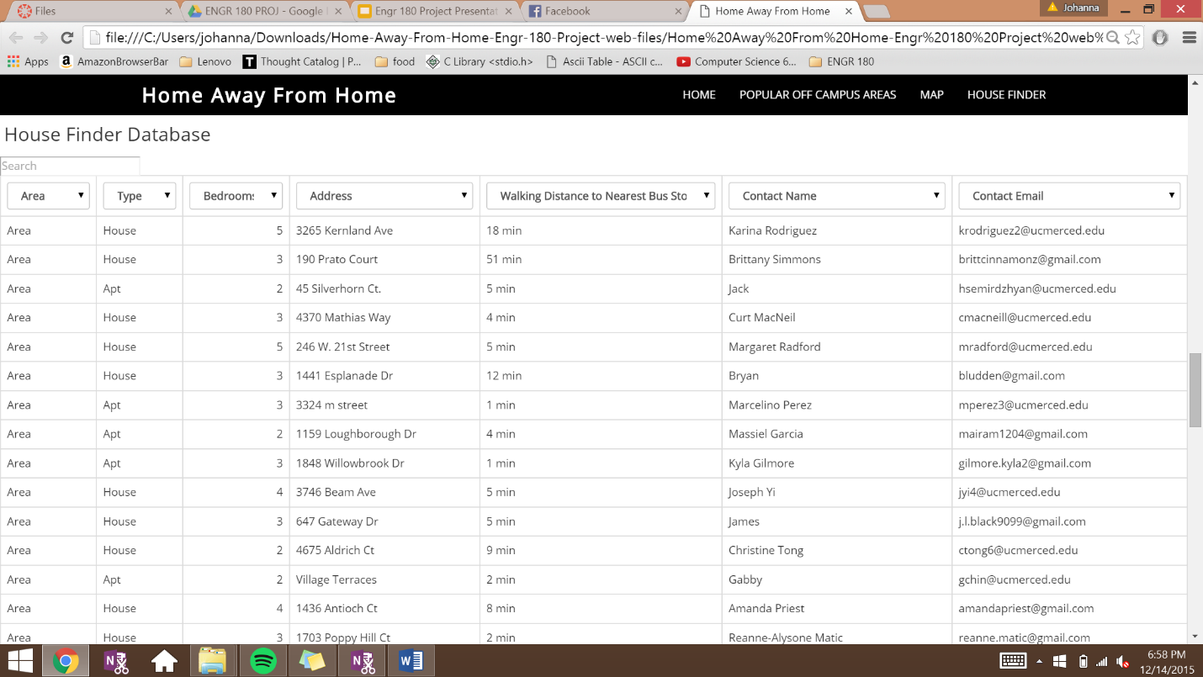Future advances that can be done to the map would be to modify the markers so that the crimes can be filtered by type. For example, displaying only crimes that are related to assault. In addition, we would like to add the trail of each Cattrack so the users know where they can be transported based on the Cattracks near their desired location. For instance, if a student wants to live in Bellevue, the map should be able to display the route of the Cattrack stops near Bellevue.

Lastly, our web application displayed a searchable database of all the housing information we gathered. Through this database, the user is able to search for a house or apartment based on their preferences of housing area, amount of available bedrooms and nearest bus stop. The house finder section of our website was the most difficult to build. Since we were all inexperienced with JAVA Script, we had to search for pieces of code and references online. The snippet of code we referenced from jqueryscript.net was modified to create a table with a filter. In addition, we combined this snippet of code with another snippet of code we referenced from jsfiddle.net which created a search bar for more specific searches. By combining both codes we were able to create an interactive database with a search bar and filters to facilitate the decision of students.

Since this was the most difficult portion of our project, it was the part with most issues. With respects to the filters, we were only able to make limited modifications. Therefore, when inputting a column of information, it would be required to have a “filter”. However, this filter consisted of every single content within that column. Future advances to the database would be to create reasonable filters with ranges. For example, removing contact name, contact email and address as filters; in addition, the remaining filters could have individual ranges that would suit the filters best. By fixing the filters, the data table would be more efficient.

Additional improvements which could be made to the database would be the available data. As mentioned before, we were not able to obtain an API from neither housing database nor the crime mapping website; therefore, all the data which was collected and inputted into our database is static. To improve this issue, we would create a database that is user-based, meaning a landlord can insert their house for rent listing and also be able delete the listing from the database once their house is no longer available for rent.

# conclusion

The purpose of our project is to provide UC Merced students with an efficient tool that would guide them in searching for housing off-campus which would best suit their needs. Through this project we learned more about spatial analysis through the results we collected; in addition, we began to learn new languages in the development of the web application. Through the process of our project we faced a few issues that limited the extent of our project. As we collected the data and developed the web application we thought of ideas that had not been previously proposed. For instance, we would like to add more data, such as house prices; in addition, we would modify the web app by making the map more interactive and the database more efficient. A major goal for future advances with this web application would be to make it public to students and users who could upload data to a database.

# Resources

CrimeMapping.com - National Map. (n.d.). Retrieved December 2, 2015, from <http://www.crimemapping.com/map.aspx?aid=38fcd6f2-9412-4d6c-b19a-f3194549e926>

Free CSS. (2015). Retrieved December 5, 2015, from <http://www.free-css.com/>

Google Maps Embed API | Google Developers. (2014, July 24). Retrieved December 2, 2015, from <https://developers.google.com/maps/documentation/embed/>

Google Maps JavaScript API V3 Reference. (2015, December 15). Retrieved December 6, 2015, from <https://developers.google.com/maps/documentation/javascript/reference#SymbolPath>

Google My Maps. (n.d.). Retrieved December 16, 2015, from <https://www.google.com/maps/d/u/0/?hl=en_US&app=mp>

HTML Color Mixer. (2015). Retrieved December 9, 2015, from <http://www.w3schools.com/tags/ref_colormixer.asp>

HTML(5) Tutorial. (2015). Retrieved December 2, 2015, from <http://www.w3schools.com/html/default.asp>

Han, R. (2014). Build a simple GIS web application using GeoDjango and Google Maps¶. Retrieved December 11, 2015, from <http://invisibleroads.com/tutorials/geodjango-googlemaps-build.html>

Simple jQuery Dropdown Table Filter Plugin (2015). Retrieved December 5, 2015, from <http://www.jqueryscript.net/table/Simple-jQuery-Dropdown-Table-Filter-Plugin-ddtf-js.html>

UC Merced CatTracks. (2015). Retrieved December 5, 2015, from <http://cattracks.ucmerced.edu/>

UC Merced Off Campus Housing (OCH) System. (2015). Retrieved December 9, 2015, from <http://housing.ucmerced.edu/housing/campus-housing/finding-place/campus-housing-och-system>